Accessorial Management

The system comes with a set of pre-configured accessorial fees. Users should first review the accessorial fees to determine if a particular fee can be used rather than adding a new one.
For example, Unloading Fee is the same as Lumper Fee. The Accessorial page is where users go to add new accessorial set up if one does not exist or can’t use a pre-configured accessorial fee.

Add New Fee
Go to the Accessorials Maintenance Page and click on Add.
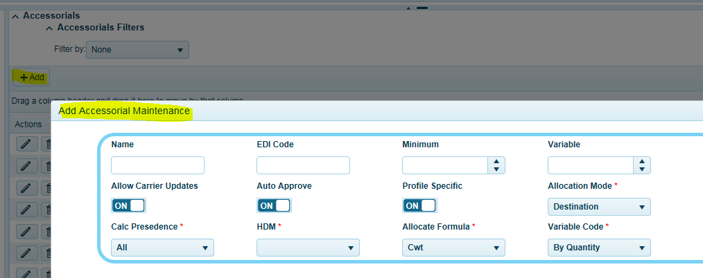
Insert a fee name. Enter in EDI Code. The following variable will be used as defaults when configuring carrier specific settings for tariffs or for carrier automation. Defaults may be replaced with a custom value for each tariff or lane fee as needed.
- Minimum: default value inserted into tariff or lane fees for the minimum charge.
- Variable: This is the default cost variable used for the Variable Code calculation factor. For example; when the Variable Code is set to weight the Variable value will be multiplied by the value in the weight for the order or load. value will be used as the defaults when setting up or adding fees at the carrier level.
- Auto Approve: select on or off to configure a default value for carrier freight bill processing automation in the Web Settlement page or via EDI 210 processing. When off all fees entered by the carrier must be approved before the freight bill will pass audit, via the Fee Approval page.
The following settings are used globally by the system
- Profile Specific – On, means this is a profile specific fee and can be assigned at the lane level or order level. Must add to each carrier fee set up in the tariff if you plan to use this fee as a profile fee.
- Allocation Mode: See Variable code section below for more details
  - None: not allocated, typically for order specific fees.
  - Load: allocate for all orders on the Shipment ID.
  - Destination: allocate for each matching delivery address (street address and zip code).
  - Origin: allocate for each matching pickup address (street address and zip code)
- Allocation Formula: The factor, like weight, used to determine the percentage of allocation.
- Calc Precedence: See Variable code section below for more details

Accessorial fees are divided into Tariff, Lane, Profile, and Order specific fees. Tariff specific fees are associated with carriers. These fees are typically calculated in advance such as fuel or stops. Lane fees are location specific regardless of carrier. Profile Fees are fees that can be associated with a carrier’s tariff and assigned as part of the carrier selection process. Order specific fees are associated with an order and are typically fees determined upon delivery i.e. detention or unloading etc. All accessorial fees may be applied to other orders on a shipment based on the allocation method of the fee.

API Fee Cross Reference
TMS comes loaded with a set of pre-determined LTL carrier fees for using API connectivity. User must apply the cross reference of the API fee to that of fees for a carrier that is not using API connectivity, such as tariff in TMS.
Click on Edit to edit a fee.
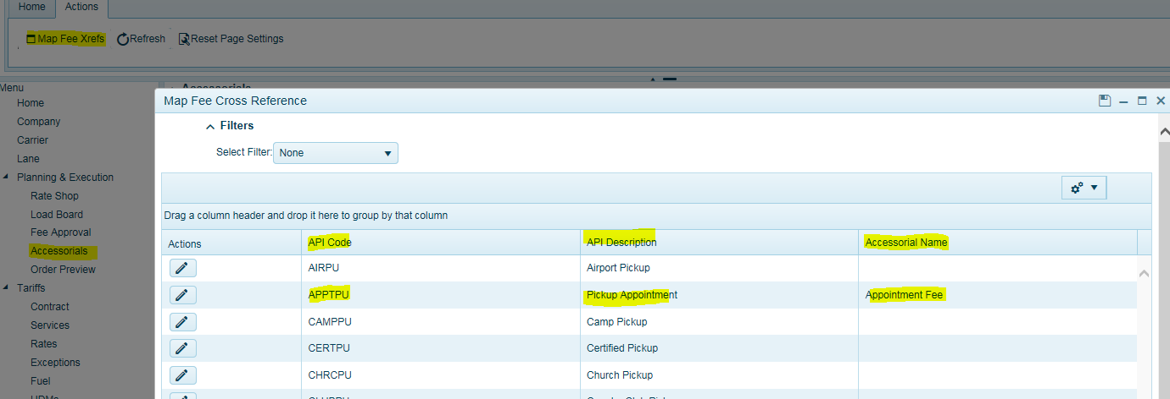
A drop-down list will display fees loaded for the TMS tariff. Select the matching fee and click save.
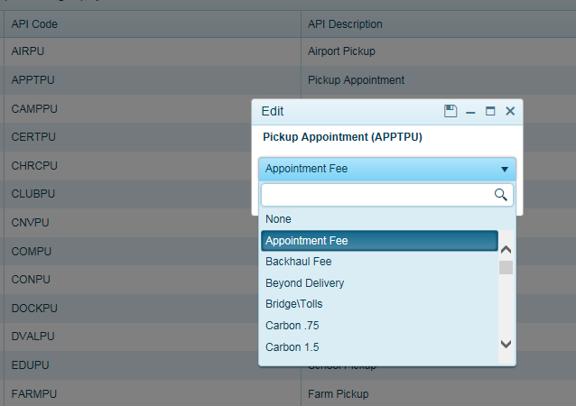

Legacy Accessorials
Stop charges, pick charges, fuel surcharges have specific allocation rules that should not be modified.
Legacy Stop fee:
- Any accessorial (codes 20-28) like stop X fee is considered a legacy stop fee
- legacy stop fees use specific variable codes formulas 7-16 with names like Stop X Flat fee. These variable codes settings should match the accessorial codes settings with the same stop # For Example, stop 1 fee should be assigned the accessorial code formula of stop 1 flat fee (current v6.0 system logic)
- legacy stop fees are always allocated by destination, so the fee allocation type is ignored. The system will reset this value when costs are recalculated if it is changed.
- legacy stop fees are always allocation type of destination and always have allocation formula of weight. (user settings are ignored or will be modified by the system to reflect default values) The system will reset this value when costs are recalculated if it is changed.
- fee calculation type for stop fees is always set to unique
- stop fees are adjusted for rounding errors automatically with any discrepancy being applied to the order with the heaviest weight at that specific destination
- The allocated cost will be stored in the fee value
- The system will use the highest configured stop fee available if there are additional stops that do not have fees configured in the carrier tariff contract. For example, if you have 4 stops configured but build a 5 stop load, the system will use the stop 4 fee$ amount for stop 5.
Legacy Fuel Surcharge Fee (The standard Rate Per Mile and Rate Percent fuel fees)
- The Fee Allocation Type is always Load. The system will reset this value when costs are recalculated if it is changed.
- The Fee Calculation Type is always Unique. The system will reset this value when the costs are recalculated if it is changed
Legacy Pickup Fee (The standard Pick 1, Pick 2 etc… fee):
- The Fee Allocation Type is always Origin. The system will reset this value when costs are recalculated if it is changed.
The Fee Calculation Type is always Unique. The system will reset this value when the costs are recalculated if it is changed

Variable code:
The variable code is used to set up the calculation formula used to calculate the accessorial fee. The calculation formula uses the Formula Variable to determine the total cost of the fee to be applied. The system then uses an allocation formula to determine how the total is allocated across similar locations defined by the allocation mode.
For Example: a calculation formula could be 10 percent of the carrier cost, but the allocation could be by weight across all similar destination locations. The system adds up the total carrier cost for the destination, get 10 percent, and then allocate the 10 percent by weight across all destinations.
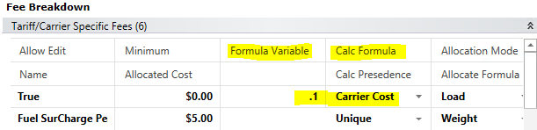

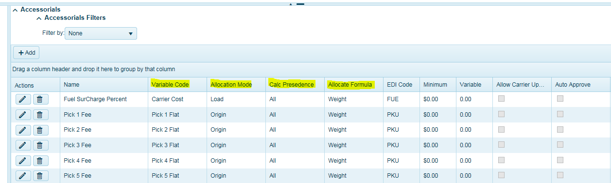

Fee Allocation Mode
- None = not allocated
- Origin = allocated by origin
- Destination = allocated by destination
- Load = allocated across entire load (CNS)

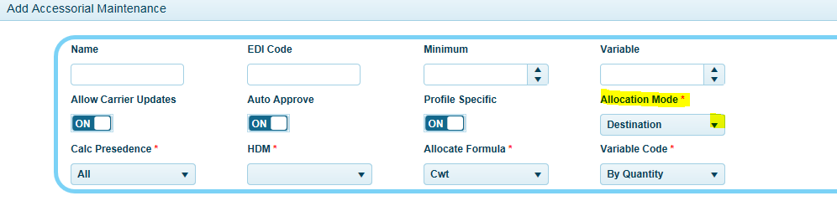

Fee Allocation Formula
Fee allocation formula uses allocation bracket type to determine what metric value is used in the allocation calculation
      - Pallets
      - Volume
      - Quantity
      - Weight; Pounds; CWT (hundred weight)
      - Distance
      - Even = allocate evenly by # of orders defined by the fee allocation type For Example: if the fee allocation type is destination, and there are 2 orders being delivered to the same location, an even allocation formula would allocate 50% of the fee value to each order
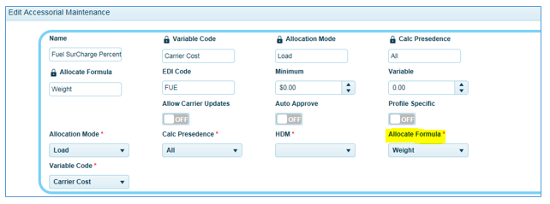
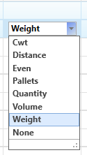

Fee Calculation Precedence
Fee Calculation type: fees are calculated based on one of the following settings
- All = combine all fees together (default)
- Unique = only one fee will be included based on the accessorial type. Duplicates will be ignored and marked as overwritten For example: if there is an unloading fee at lane level and unloading at order level, only the order level unloading fee will be applied There is an order of precedence used to resolve conflict with fee calculation types. This precedence is order, Lane, Tariff.
  - Any fee marked as unique will only be overwritten if the exact fee exists at the order level or lane level. If the user deletes the previous overwritten fee, it will be reset back to originals.
  - Exception to the rule – NEXTrack self-service carrier fee submittal process may affect how these fees are calculated to be defined.
- Carrier over lane = carrier fees have the ability to override lane fees and will combine with order specific fees. For example: if there is a carrier unloading charge and lane unloading charge and an order unloading charge; the carrier and order unloading charge will be added together and the lane charge will be ignored, and the lane fee will be marked as overwritten. Note: the order specific fee is not required for this calculation type
- Lane over Carrier = lane fees have the ability to override carrier fees and will combine with order specific fees. For example: if there is a carrier unloading charge and lane unloading charge and an order unloading charge; the lane and order unloading charge will be added together and the carrier charge will be ignored, and the carrier fee will be marked as overwritten. Note: the order specific fee is not required for this calculation type
- Carrier over all = carrier fee will always overwrite lane and order specific fees
- Lane over all = lane fees will always overwrite carrier and orders specific fees
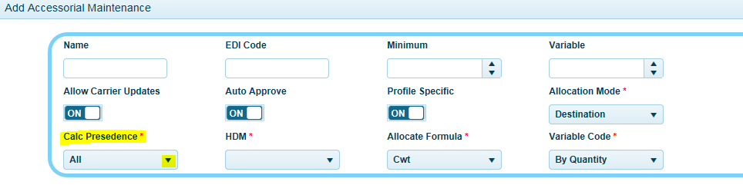
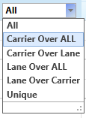

Tariff/Carrier Specific Fees

Tariff/carrier specific fees are configured, maintained, and set up in each carrier tariff contract.
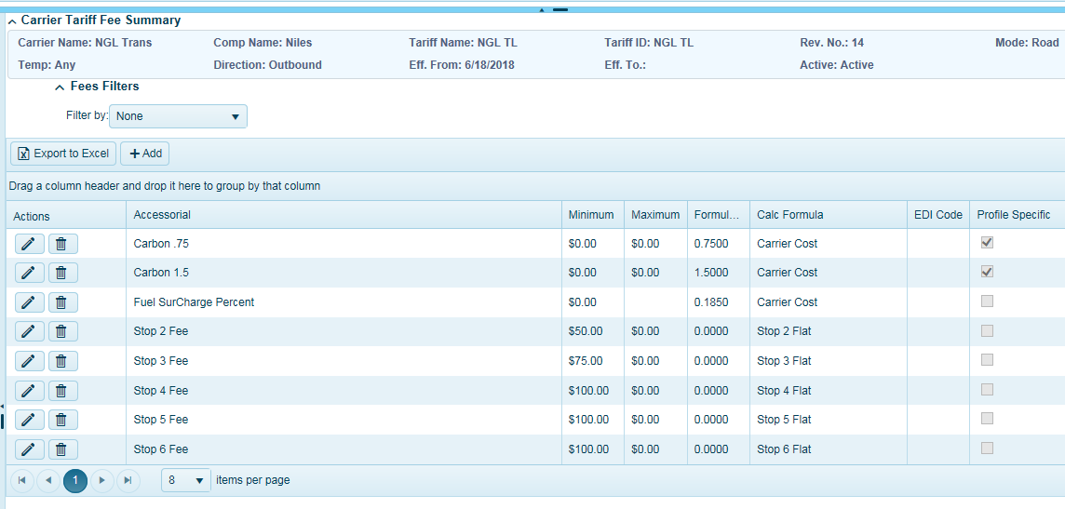
Tariff fees are assigned when a carrier is selected or when the Recalculate Using Tariff procedure is selected from the Ribbon bar. Tariff fees cannot be edited at the order level once they have been assigned. Attempts to edit a Tariff specific fee will automatically create an Order specific fee that Overrides (replaces) the assigned Tariff specific fee. Once an override has been created updates to tariff specific fees, including fuel surcharge updates, will not be applied to the order and possibly the entire load. An order specific fee will always override (replace) any matching Tariff specific fee. So, if we override a Tariff specific unloading charge this new Order specific fee will always be used to calculate the unloading charge unless the Order specific fee is removed.
There are two ways to remove an order specific fee: (1) Re-set the order or Load to “N” status this will remove all Order and Tariff specific fees; (2) Manually remove Order specific fees from each order by selecting the fee and clicking the delete key on the keyboard. It is important to note that on consolidated loads if the allocation method is set to allocate across more than one order or stop the system may try to replace the fee after it is deleted. If this happens you must use option (1) and reset to N status.

Lane Fees

Lane Fees are maintained in the Lane Fees pane under Lane Maintenance. These fees are location specific and are only assigned to an order once, when the order is first imported. An example would be Canadian Tax calculation by Providence or locations specific unloading fee regardless of carrier.
Lane fees are not assigned to orders that are created manually; orders that are created using the “Duplicate Pro Number” procedure; or orders that are created using the “Create a new Sequence” procedure. Lane Fees cannot be modified they can only be overridden (replaced) by an Order Specific Fee. To override a Lane Fee open the order’s Revenue Tab, attempt to edit the Lane Fees minimum value, tab out of the minimum value field and expand the Order specific fee data grid. The system will automatically generate a new Order specific fee that can be edited with the desired cost structure; the original Lane Fee will be displayed in Red and marked ads overridden. If the Lane Fee has a cost allocation formula that will affect other orders these orders will also be assigned an Order specific fee override.
When an order or a load is returned to N status, “The carrier is Unassigned”, all Tariff and Order specific fees will be removed, while the order is in N status the Lane Fee will still display Red and will be marked as overridden until a new carrier has been assigned. During recalculation the system will determine if the original Lane Fee can be used or if a new Order specific fee is required. Order specific fees are required if a conflict between multiple Lane Fees are found on the same load with similar configuration setting. Like when there are two different unloading fees allocated across the same stop. The system will create an Order specific fee during allocation that will reflect the highest cost. Users may then modify the Order specific fee as needed.
If all the Order specific fees associated with an overridden Lane Fee are removed the system will attempt to use the original Lane Fee where possible unless another conflict with allocation is detected. Again the system will attempt to resolve the conflict by creating Order specific fees as needed. Under some conditions the only way to resolve Lane Fee conflicts on consolidated loads is by the use of an Order specific fee.
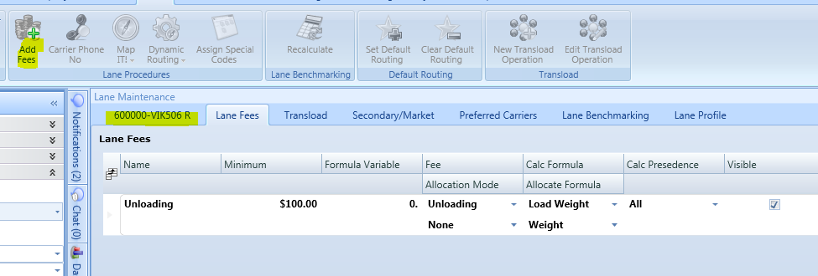

Lane Profile Specific Fees
Profile specific Fees are associated with a Lane and a Tariff. The lane data determines what locations are affected by the Fee and the Tariff determines the cost configuration of the Fee. When a tariff is selected the system searches for a match between both the Tariff and the Lane to determine if a fee should be assigned to the order. A fee is only assigned if both the Lane and Tariff are configured to use the fee. An example would be a Lift Gate Fee. If the location requires a Lift Gate the lane would be configured with the Lift Gate Profile Specific Fee. Then each carrier that provided Lift Gate Service would add the fee to the Tariff Fees configuration. When selecting the carrier manually a message is displayed on the carrier selection screen for carriers that do not have Lift Gate Service.
The system does not prevent carriers from being assigned or selected if they are not configured with a cost for a Profile specific Fee; the software assumes that the fee is zero. So, when setting up lowest cost carrier selection lanes it is important to understand how Profile specific Fees may or may not affect lowest cost carrier costing.
An administrative tool called HDM Maintenance is available to assist with maintaining Lane Profile Specific Fees by zip code. This tool provides a way to mass update Fees at the Lane level when requirements change. An example would be Henry Hudson Bridge tolls in New York. A list of New York zip codes affected by the fee could be entered in the HDM Maintenance tool and the fee could be automatically added to each affected Lane. Each tariff could then be configured with a unique cost for the toll; some equipment may need to pay higher tolls than other. When this configuration is properly assigned to both Lanes and Tariffs the Profile specific Fee will be automatically included in the carrier’s estimated cost.
The process for over ridding Profile specific fees will follow the same rules as over ridding Tariff specific Fees. Also, Profile specific Fees will be grouped and displayed together with Tariff specific Fees on the Revenue tab, they will not be displayed with the Lane Fees.
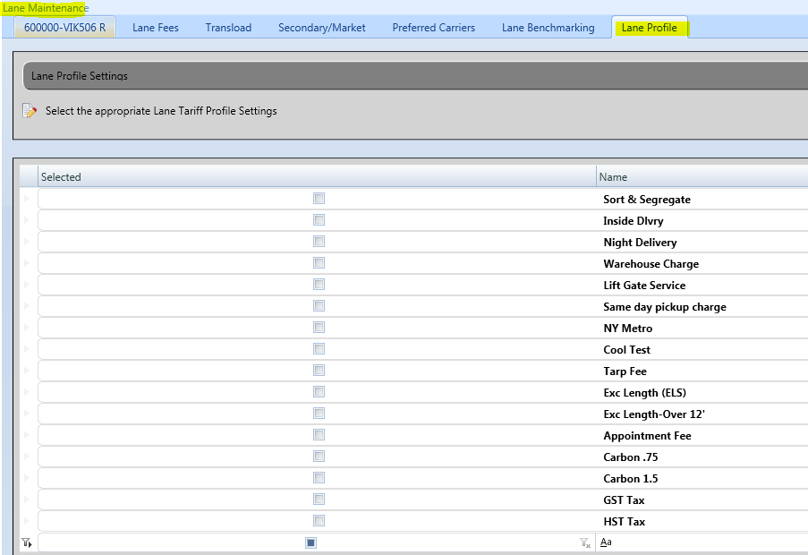

Order Specific Fees

Order specific fees – are additional fees that are needed. These are simple fees that can be added to specific orders. They are not associated to a carrier or lane. Select the add fees button in the ribbon bar and add the fee needed. To delete the fee, select the fee under order specific fees and click the delete button on the keyboard. Order Specific fees are typically determined following a delivery i.e. unloading, detention, or Liftgate Service (if never originally applied).

